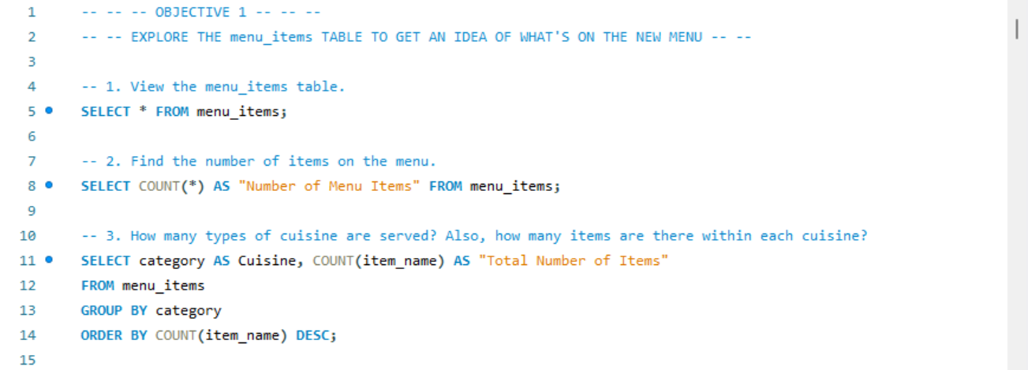

|  |  |  |  |
| --- | --- | --- | --- |
| menu_item_id | item_name | category | price |
| 101 | Hamburger | American | 12.95 |
| 102 | Cheeseburger | American | 13.95 |
| 103 | Hot Dog | American | 9.00 |
| 104 | Veggie Burger | American | 10.50 |
| 105 | Mac & Cheese | American | 7.00 |
| 106 | French Fries | American | 7.00 |
| 107 | Orange Chicken | Asian | 16.50 |
| 108 | Tofu Pad Thai | Asian | 14.50 |
| 109 | Korean Beef Bowl | Asian | 17.95 |
| 110 | Pork Ramen | Asian | 17.95 |
| 111 | California Roll | Asian | 11.95 |
| 112 | Salmon Roll | Asian | 14.95 |
| 113 | Edamame | Asian | 5.00 |
| 114 | Potstickers | Asian | 9.00 |
| 115 | Chicken Tacos | Mexican | 11.95 |
| 116 | Steak Tacos | Mexican | 13.95 |
| 117 | Chicken Burrito | Mexican | 12.95 |
| 118 | Steak Burrito | Mexican | 14.95 |
| 119 | Chicken Torta | Mexican | 11.95 |
| 120 | Steak Torta | Mexican | 13.95 |
| 121 | Cheese Quesadillas | Mexican | 10.50 |
| 122 | Chips & Salsa | Mexican | 7.00 |
| 123 | Chips & Guacamole | Mexican | 9.00 |
| 124 | Spaghetti | Italian | 14.50 |
| 125 | Spaghetti & Meatballs | Italian | 17.95 |
| 126 | Fettuccine Alfredo | Italian | 14.50 |
| 127 | Meat Lasagna | Italian | 17.95 |
| 128 | Cheese Lasagna | Italian | 15.50 |
| 129 | Mushroom Ravioli | Italian | 15.50 |
| 130 | Shrimp Scampi | Italian | 19.95 |
| 131 | Chicken Parmesan | Italian | 17.95 |
| 132 | Eggplant Parmesan | Italian | 16.95 |
|  |  |  |  |



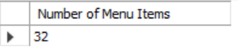



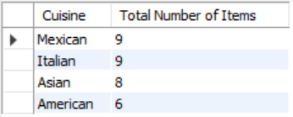

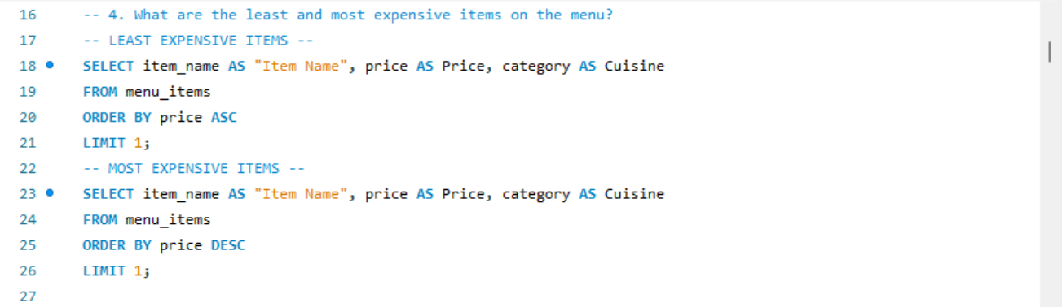







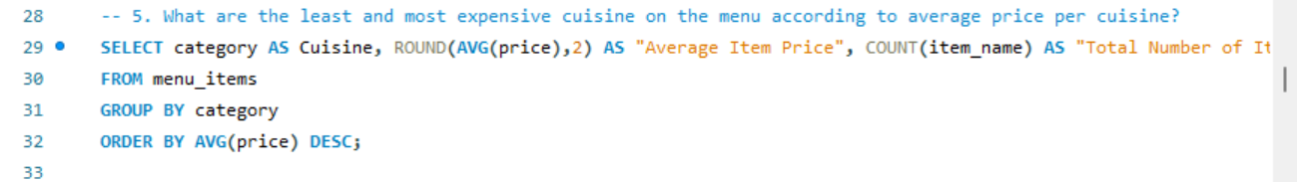

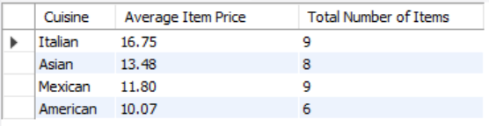

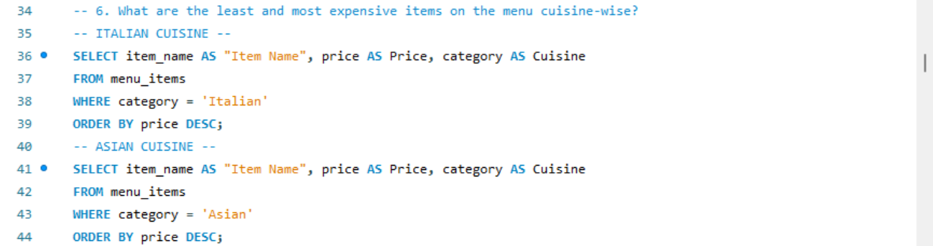

|  |  |  |
| --- | --- | --- |
| Item Name | Price | Cuisine |
| Shrimp Scampi | 19.95 | Italian |
| Spaghetti & Meatballs | 17.95 | Italian |
| Meat Lasagna | 17.95 | Italian |
| Chicken Parmesan | 17.95 | Italian |
| Eggplant Parmesan | 16.95 | Italian |
| Cheese Lasagna | 15.50 | Italian |
| Mushroom Ravioli | 15.50 | Italian |
| Spaghetti | 14.50 | Italian |
| Fettuccine Alfredo | 14.50 | Italian |



|  |  |  |
| --- | --- | --- |
| Item Name | Price | Cuisine |
| Korean Beef Bowl | 17.95 | Asian |
| Pork Ramen | 17.95 | Asian |
| Orange Chicken | 16.50 | Asian |
| Salmon Roll | 14.95 | Asian |
| Tofu Pad Thai | 14.50 | Asian |
| California Roll | 11.95 | Asian |
| Potstickers | 9.00 | Asian |
| Edamame | 5.00 | Asian |

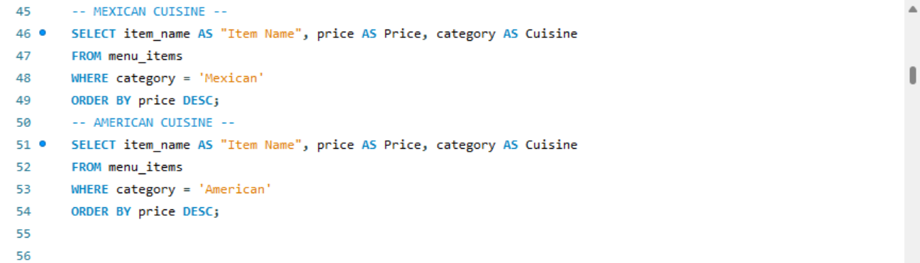

|  |  |  |
| --- | --- | --- |
| Item Name | Price | Cuisine |
| Steak Burrito | 14.95 | Mexican |
| Steak Tacos | 13.95 | Mexican |
| Steak Torta | 13.95 | Mexican |
| Chicken Burrito | 12.95 | Mexican |
| Chicken Tacos | 11.95 | Mexican |
| Chicken Torta | 11.95 | Mexican |
| Cheese Quesadillas | 10.50 | Mexican |
| Chips & Guacamole | 9.00 | Mexican |
| Chips & Salsa | 7.00 | Mexican |



|  |  |  |
| --- | --- | --- |
| Item Name | Price | Cuisine |
| Cheeseburger | 13.95 | American |
| Hamburger | 12.95 | American |
| Veggie Burger | 10.50 | American |
| Hot Dog | 9.00 | American |
| Mac & Cheese | 7.00 | American |
| French Fries | 7.00 | American |

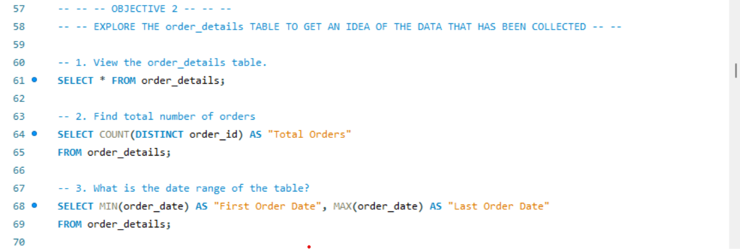

(The order table contains 12234 rows. Here, I have only included top 20 rows as above Query Result.)

|  |  |  |  |  |
| --- | --- | --- | --- | --- |
| order_details_id | order_id | order_date | order_time | item_id |
| 1 | 1 | 2023-01-01 | 11:38:36 | 109 |
| 2 | 2 | 2023-01-01 | 11:57:40 | 108 |
| 3 | 2 | 2023-01-01 | 11:57:40 | 124 |
| 4 | 2 | 2023-01-01 | 11:57:40 | 117 |
| 5 | 2 | 2023-01-01 | 11:57:40 | 129 |
| 6 | 2 | 2023-01-01 | 11:57:40 | 106 |
| 7 | 3 | 2023-01-01 | 12:12:28 | 117 |
| 8 | 3 | 2023-01-01 | 12:12:28 | 119 |
| 9 | 4 | 2023-01-01 | 12:16:31 | 117 |
| 10 | 5 | 2023-01-01 | 12:21:30 | 117 |
| 11 | 6 | 2023-01-01 | 12:29:36 | 101 |
| 12 | 6 | 2023-01-01 | 12:29:36 | 114 |
| 13 | 7 | 2023-01-01 | 12:50:37 | 123 |
| 14 | 8 | 2023-01-01 | 12:51:37 | 123 |
| 15 | 9 | 2023-01-01 | 12:52:01 | 108 |
| 16 | 9 | 2023-01-01 | 12:52:01 | 126 |
| 17 | 9 | 2023-01-01 | 12:52:01 | 110 |
| 18 | 9 | 2023-01-01 | 12:52:01 | 117 |
| 19 | 9 | 2023-01-01 | 12:52:01 | 117 |
| 20 | 9 | 2023-01-01 | 12:52:01 | 129 |
|  |  |  |  |  |









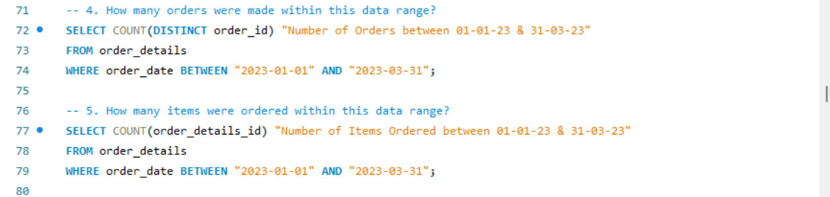







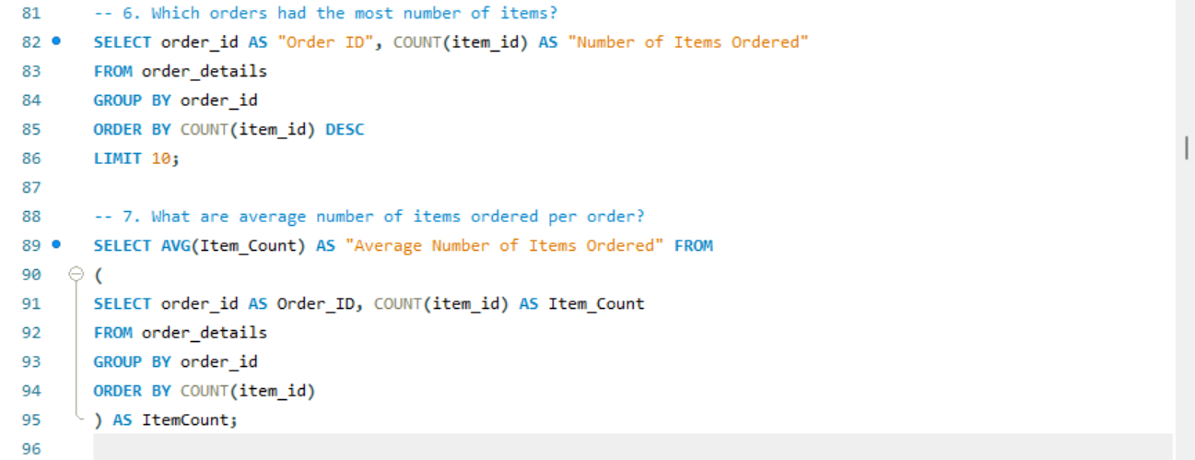

|  |  |
| --- | --- |
| Order ID | Number of Items Ordered |
| 2675 | 14 |
| 443 | 14 |
| 1957 | 14 |
| 3473 | 14 |
| 330 | 14 |
| 440 | 14 |
| 4305 | 14 |
| 1274 | 13 |
| 2126 | 13 |
| 1734 | 13 |

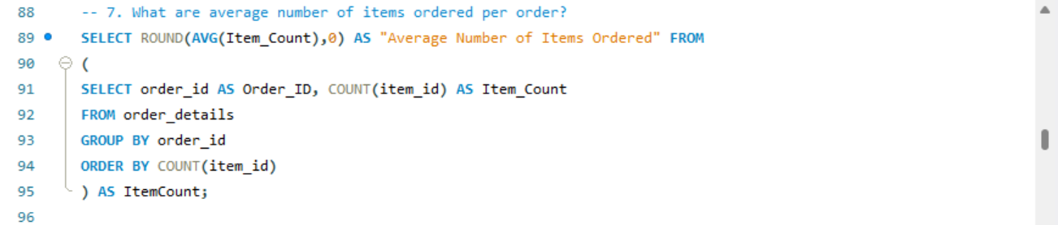



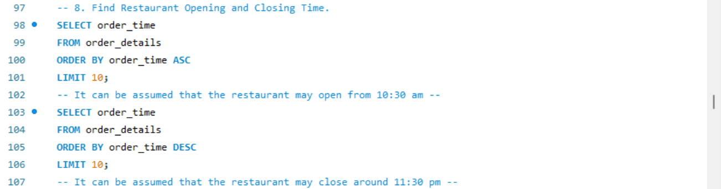

|  |
| --- |
| order_time |
| 10:50:46 |
| 10:50:46 |
| 10:50:46 |
| 10:54:03 |
| 10:54:03 |
| 11:15:19 |
| 11:15:19 |
| 11:15:19 |
| 11:15:19 |
| 11:15:43 |



|  |
| --- |
| order_time |
| 23:05:24 |
| 23:05:24 |
| 23:05:24 |
| 23:05:17 |
| 23:05:17 |
| 23:05:17 |
| 23:02:35 |
| 23:02:35 |
| 23:02:35 |
| 23:02:31 |

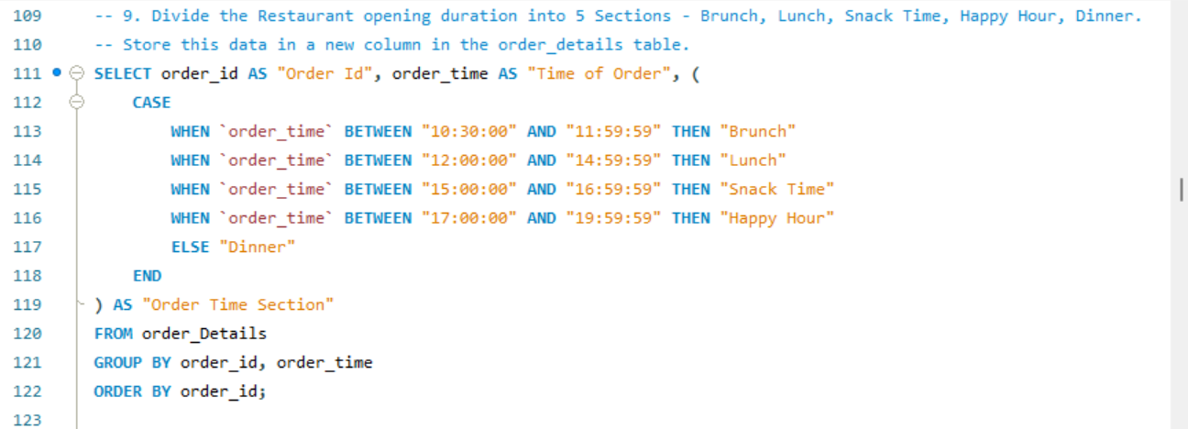

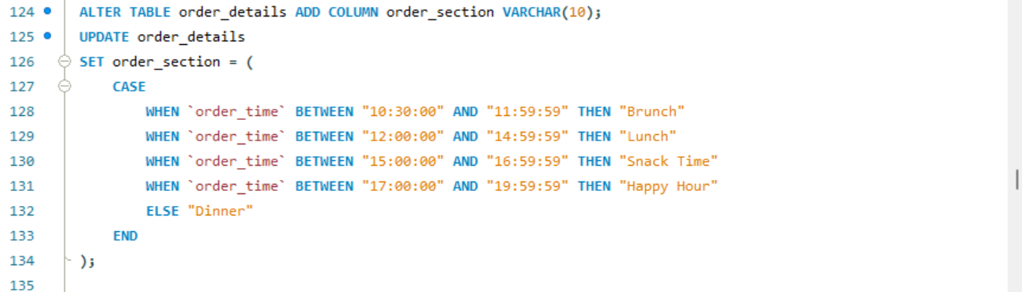

(Included only Top 20 rows from Query Result.)

|  |  |  |
| --- | --- | --- |
| Order ID | Time of Order | Order Time Section |
| 1 | 11:38:36 | Brunch |
| 2 | 11:57:40 | Brunch |
| 3 | 12:12:28 | Lunch |
| 4 | 12:16:31 | Lunch |
| 5 | 12:21:30 | Lunch |
| 6 | 12:29:36 | Lunch |
| 7 | 12:50:37 | Lunch |
| 8 | 12:51:37 | Lunch |
| 9 | 12:52:01 | Lunch |
| 10 | 13:00:15 | Lunch |
| 11 | 13:02:59 | Lunch |
| 12 | 13:04:41 | Lunch |
| 13 | 13:11:55 | Lunch |
| 14 | 13:14:19 | Lunch |
| 15 | 13:33:00 | Lunch |
| 16 | 13:34:07 | Lunch |
| 17 | 13:53:00 | Lunch |
| 18 | 13:57:08 | Lunch |
| 19 | 13:59:09 | Lunch |
| 20 | 14:03:08 | Lunch |

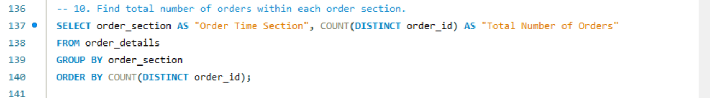

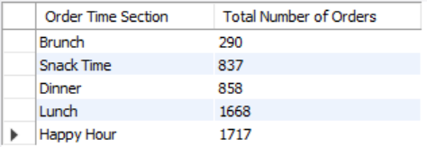

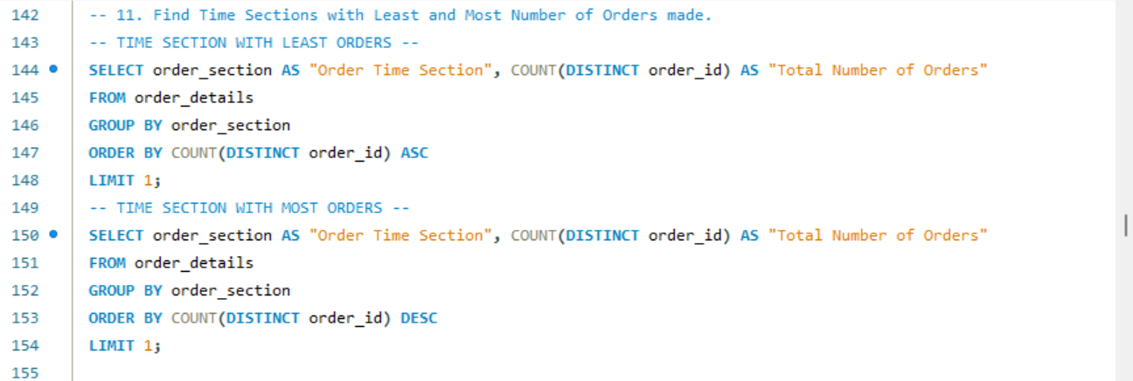







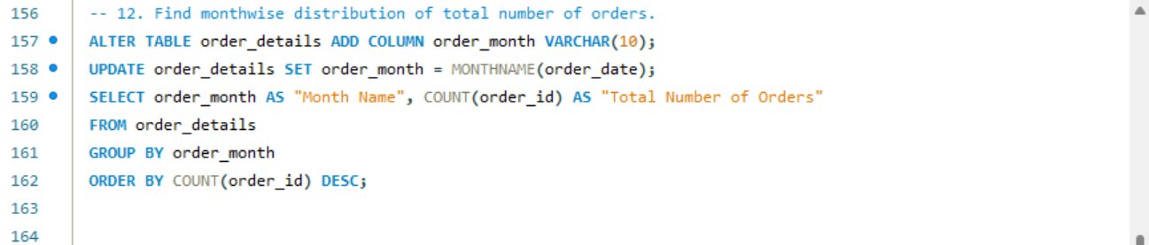

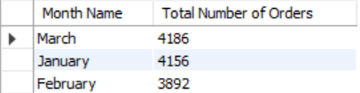

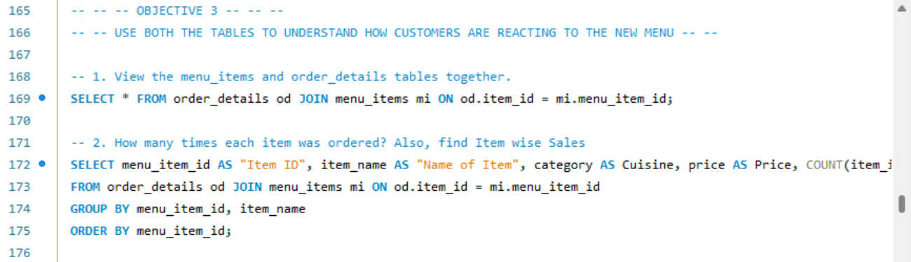

(Included only Top 20 rows from Query Result.)

|  |  |  |  |  |  |  |  |  |  |  |
| --- | --- | --- | --- | --- | --- | --- | --- | --- | --- | --- |
| order_details_id | order_id | order_date | order_time | item_id | order_section | order_month | menu_item_id | item_name | category | price |
| 1 | 1 | 2023-01-01 | 11:38:36 | 109 | Brunch | January | 109 | Korean Beef Bowl | Asian | 17.95 |
| 2 | 2 | 2023-01-01 | 11:57:40 | 108 | Brunch | January | 108 | Tofu Pad Thai | Asian | 14.50 |
| 3 | 2 | 2023-01-01 | 11:57:40 | 124 | Brunch | January | 124 | Spaghetti | Italian | 14.50 |
| 4 | 2 | 2023-01-01 | 11:57:40 | 117 | Brunch | January | 117 | Chicken Burrito | Mexican | 12.95 |
| 5 | 2 | 2023-01-01 | 11:57:40 | 129 | Brunch | January | 129 | Mushroom Ravioli | Italian | 15.50 |
| 6 | 2 | 2023-01-01 | 11:57:40 | 106 | Brunch | January | 106 | French Fries | American | 7.00 |
| 7 | 3 | 2023-01-01 | 12:12:28 | 117 | Lunch | January | 117 | Chicken Burrito | Mexican | 12.95 |
| 8 | 3 | 2023-01-01 | 12:12:28 | 119 | Lunch | January | 119 | Chicken Torta | Mexican | 11.95 |
| 9 | 4 | 2023-01-01 | 12:16:31 | 117 | Lunch | January | 117 | Chicken Burrito | Mexican | 12.95 |
| 10 | 5 | 2023-01-01 | 12:21:30 | 117 | Lunch | January | 117 | Chicken Burrito | Mexican | 12.95 |
| 11 | 6 | 2023-01-01 | 12:29:36 | 101 | Lunch | January | 101 | Hamburger | American | 12.95 |
| 12 | 6 | 2023-01-01 | 12:29:36 | 114 | Lunch | January | 114 | Potstickers | Asian | 9.00 |
| 13 | 7 | 2023-01-01 | 12:50:37 | 123 | Lunch | January | 123 | Chips & Guacamole | Mexican | 9.00 |
| 14 | 8 | 2023-01-01 | 12:51:37 | 123 | Lunch | January | 123 | Chips & Guacamole | Mexican | 9.00 |
| 15 | 9 | 2023-01-01 | 12:52:01 | 108 | Lunch | January | 108 | Tofu Pad Thai | Asian | 14.50 |
| 16 | 9 | 2023-01-01 | 12:52:01 | 126 | Lunch | January | 126 | Fettuccine Alfredo | Italian | 14.50 |
| 17 | 9 | 2023-01-01 | 12:52:01 | 110 | Lunch | January | 110 | Pork Ramen | Asian | 17.95 |
| 18 | 9 | 2023-01-01 | 12:52:01 | 117 | Lunch | January | 117 | Chicken Burrito | Mexican | 12.95 |
| 19 | 9 | 2023-01-01 | 12:52:01 | 117 | Lunch | January | 117 | Chicken Burrito | Mexican | 12.95 |
| 20 | 9 | 2023-01-01 | 12:52:01 | 129 | Lunch | January | 129 | Mushroom Ravioli | Italian | 15.50 |



|  |  |  |  |  |  |
| --- | --- | --- | --- | --- | --- |
| Item ID | Name of Item | Cuisine | Price | Number of Times Ordered | Total Sales |
| 101 | Hamburger | American | 12.95 | 622 | 8054.90 |
| 102 | Cheeseburger | American | 13.95 | 583 | 8132.85 |
| 103 | Hot Dog | American | 9.00 | 257 | 2313.00 |
| 104 | Veggie Burger | American | 10.50 | 238 | 2499.00 |
| 105 | Mac & Cheese | American | 7.00 | 463 | 3241.00 |
| 106 | French Fries | American | 7.00 | 571 | 3997.00 |
| 107 | Orange Chicken | Asian | 16.50 | 456 | 7524.00 |
| 108 | Tofu Pad Thai | Asian | 14.50 | 562 | 8149.00 |
| 109 | Korean Beef Bowl | Asian | 17.95 | 588 | 10554.60 |
| 110 | Pork Ramen | Asian | 17.95 | 360 | 6462.00 |
| 111 | California Roll | Asian | 11.95 | 355 | 4242.25 |
| 112 | Salmon Roll | Asian | 14.95 | 324 | 4843.80 |
| 113 | Edamame | Asian | 5.00 | 620 | 3100.00 |
| 114 | Potstickers | Asian | 9.00 | 205 | 1845.00 |
| 115 | Chicken Tacos | Mexican | 11.95 | 123 | 1469.85 |
| 116 | Steak Tacos | Mexican | 13.95 | 214 | 2985.30 |
| 117 | Chicken Burrito | Mexican | 12.95 | 455 | 5892.25 |
| 118 | Steak Burrito | Mexican | 14.95 | 354 | 5292.30 |
| 119 | Chicken Torta | Mexican | 11.95 | 379 | 4529.05 |
| 120 | Steak Torta | Mexican | 13.95 | 489 | 6821.55 |
| 121 | Cheese Quesadillas | Mexican | 10.50 | 233 | 2446.50 |
| 122 | Chips & Salsa | Mexican | 7.00 | 461 | 3227.00 |
| 123 | Chips & Guacamole | Mexican | 9.00 | 237 | 2133.00 |
| 124 | Spaghetti | Italian | 14.50 | 367 | 5321.50 |
| 125 | Spaghetti & Meatballs | Italian | 17.95 | 470 | 8436.50 |
| 126 | Fettuccine Alfredo | Italian | 14.50 | 249 | 3610.50 |
| 127 | Meat Lasagna | Italian | 17.95 | 273 | 4900.35 |
| 128 | Cheese Lasagna | Italian | 15.50 | 207 | 3208.50 |
| 129 | Mushroom Ravioli | Italian | 15.50 | 359 | 5564.50 |
| 130 | Shrimp Scampi | Italian | 19.95 | 239 | 4768.05 |
| 131 | Chicken Parmesan | Italian | 17.95 | 364 | 6533.80 |
| 132 | Eggplant Parmesan | Italian | 16.95 | 420 | 7119.00 |

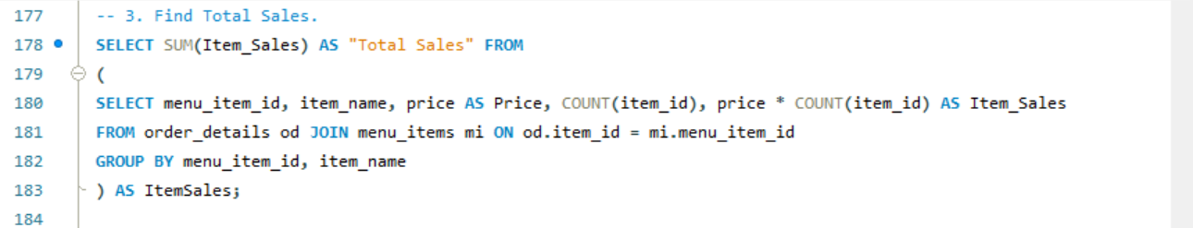



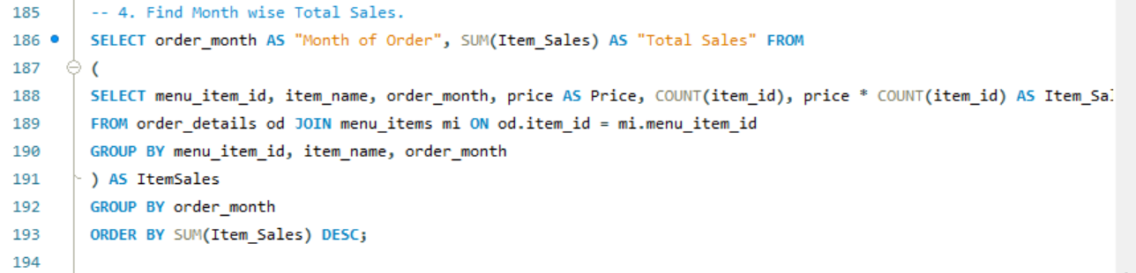

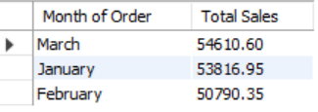

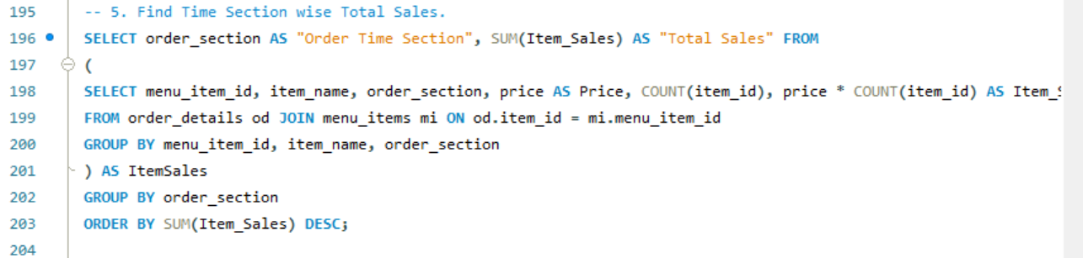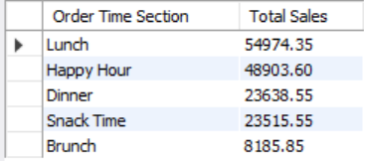

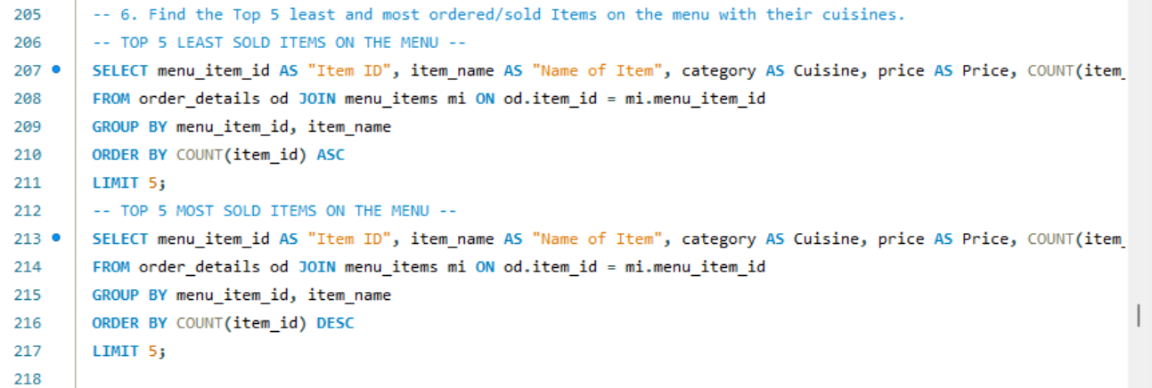

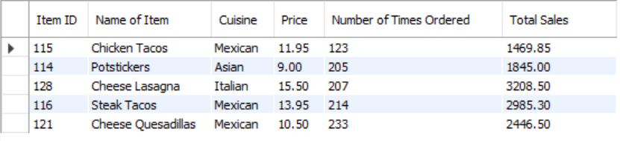



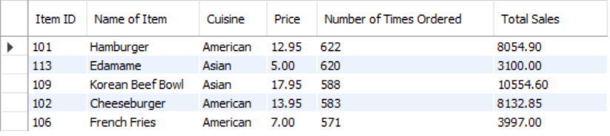

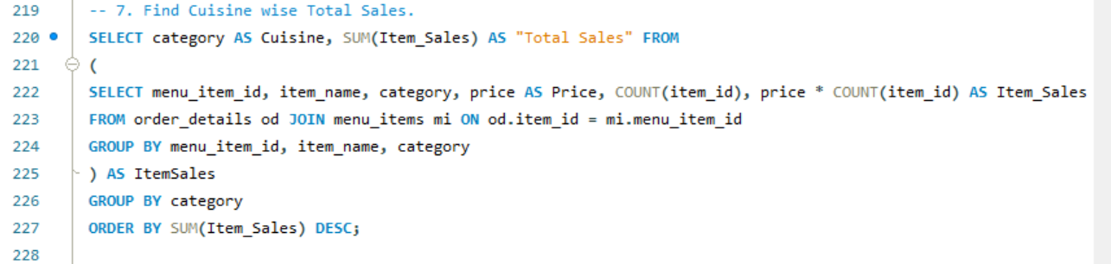

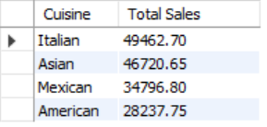

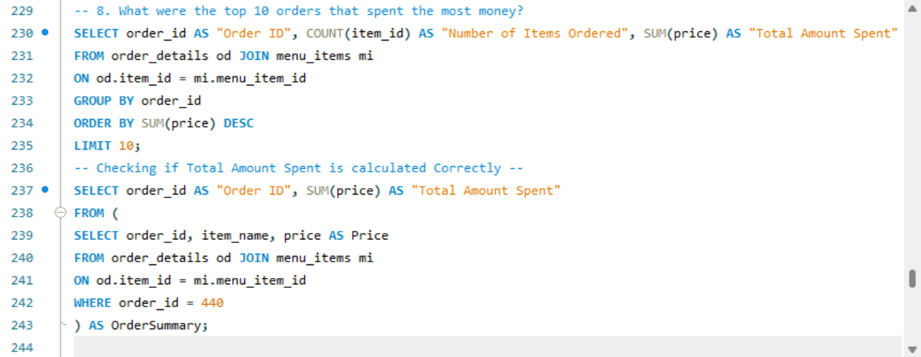

|  |  |  |
| --- | --- | --- |
| Order ID | Number of Items Ordered | Total Amount Spent |
| 440 | 14 | 192.15 |
| 2075 | 13 | 191.05 |
| 1957 | 14 | 190.10 |
| 330 | 14 | 189.70 |
| 2675 | 14 | 185.10 |
| 4482 | 13 | 184.50 |
| 1274 | 13 | 183.55 |
| 2188 | 13 | 182.65 |
| 3473 | 14 | 182.55 |
| 3583 | 13 | 179.60 |



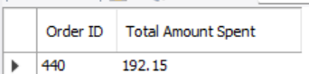

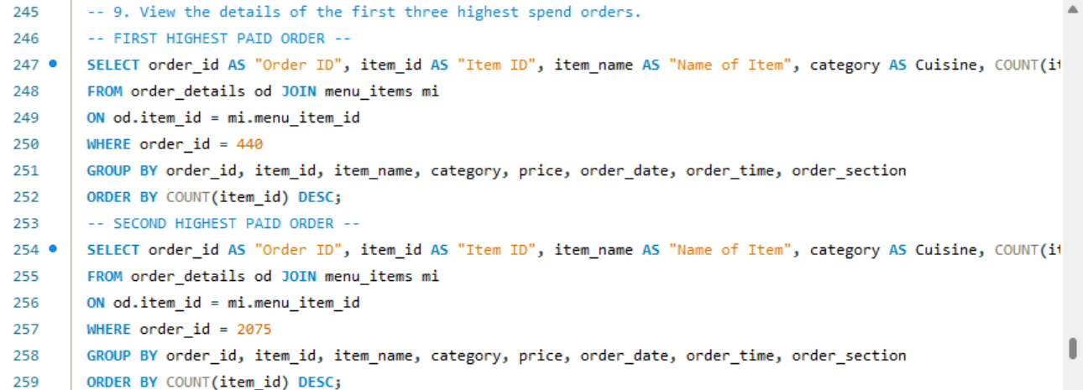

|  |  |  |  |  |  |  |  |  |  |
| --- | --- | --- | --- | --- | --- | --- | --- | --- | --- |
| Order ID | Item ID | Name of Item | Cuisine | Quantity | Date of Order | Time of Order | Order Time Section | Price | Item Total |
| 440 | 125 | Spaghetti & Meatballs | Italian | 2 | 2023-01-08 | 12:16:34 | Lunch | 17.95 | 35.90 |
| 440 | 126 | Fettuccine Alfredo | Italian | 2 | 2023-01-08 | 12:16:34 | Lunch | 14.50 | 29.00 |
| 440 | 116 | Steak Tacos | Mexican | 1 | 2023-01-08 | 12:16:34 | Lunch | 13.95 | 13.95 |
| 440 | 103 | Hot Dog | American | 1 | 2023-01-08 | 12:16:34 | Lunch | 9.00 | 9.00 |
| 440 | 124 | Spaghetti | Italian | 1 | 2023-01-08 | 12:16:34 | Lunch | 14.50 | 14.50 |
| 440 | 109 | Korean Beef Bowl | Asian | 1 | 2023-01-08 | 12:16:34 | Lunch | 17.95 | 17.95 |
| 440 | 127 | Meat Lasagna | Italian | 1 | 2023-01-08 | 12:16:34 | Lunch | 17.95 | 17.95 |
| 440 | 113 | Edamame | Asian | 1 | 2023-01-08 | 12:16:34 | Lunch | 5.00 | 5.00 |
| 440 | 122 | Chips & Salsa | Mexican | 1 | 2023-01-08 | 12:16:34 | Lunch | 7.00 | 7.00 |
| 440 | 131 | Chicken Parmesan | Italian | 1 | 2023-01-08 | 12:16:34 | Lunch | 17.95 | 17.95 |
| 440 | 106 | French Fries | American | 1 | 2023-01-08 | 12:16:34 | Lunch | 7.00 | 7.00 |
| 440 | 132 | Eggplant Parmesan | Italian | 1 | 2023-01-08 | 12:16:34 | Lunch | 16.95 | 16.95 |



|  |  |  |  |  |  |  |  |  |  |
| --- | --- | --- | --- | --- | --- | --- | --- | --- | --- |
| Order ID | Item ID | Name of Item | Cuisine | Quantity | Date of Order | Time of Order | Order Time Section | Price | Item Total |
| 2075 | 132 | Eggplant Parmesan | Italian | 2 | 2023-02-04 | 14:03:04 | Lunch | 16.95 | 33.90 |
| 2075 | 107 | Orange Chicken | Asian | 1 | 2023-02-04 | 14:03:04 | Lunch | 16.50 | 16.50 |
| 2075 | 115 | Chicken Tacos | Mexican | 1 | 2023-02-04 | 14:03:04 | Lunch | 11.95 | 11.95 |
| 2075 | 102 | Cheeseburger | American | 1 | 2023-02-04 | 14:03:04 | Lunch | 13.95 | 13.95 |
| 2075 | 124 | Spaghetti | Italian | 1 | 2023-02-04 | 14:03:04 | Lunch | 14.50 | 14.50 |
| 2075 | 125 | Spaghetti & Meatballs | Italian | 1 | 2023-02-04 | 14:03:04 | Lunch | 17.95 | 17.95 |
| 2075 | 127 | Meat Lasagna | Italian | 1 | 2023-02-04 | 14:03:04 | Lunch | 17.95 | 17.95 |
| 2075 | 129 | Mushroom Ravioli | Italian | 1 | 2023-02-04 | 14:03:04 | Lunch | 15.50 | 15.50 |
| 2075 | 111 | California Roll | Asian | 1 | 2023-02-04 | 14:03:04 | Lunch | 11.95 | 11.95 |
| 2075 | 112 | Salmon Roll | Asian | 1 | 2023-02-04 | 14:03:04 | Lunch | 14.95 | 14.95 |
| 2075 | 118 | Steak Burrito | Mexican | 1 | 2023-02-04 | 14:03:04 | Lunch | 14.95 | 14.95 |
| 2075 | 122 | Chips & Salsa | Mexican | 1 | 2023-02-04 | 14:03:04 | Lunch | 7.00 | 7.00 |

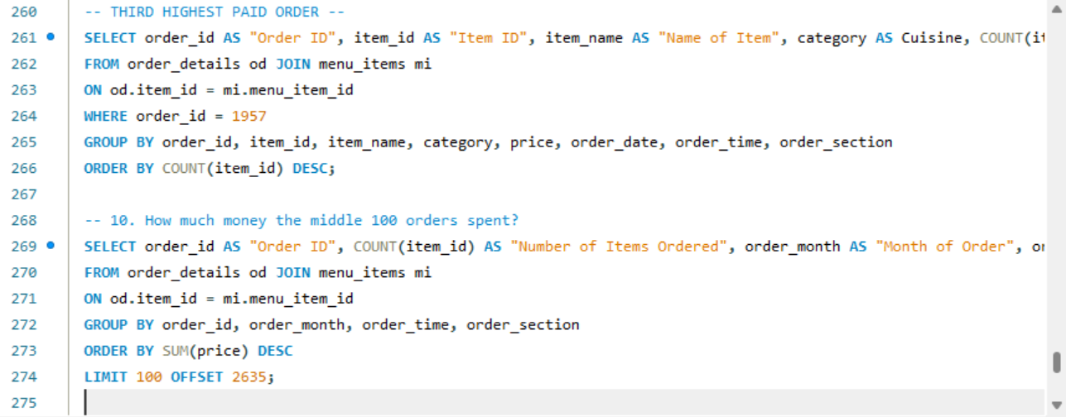

|  |  |  |  |  |  |  |  |  |  |
| --- | --- | --- | --- | --- | --- | --- | --- | --- | --- |
| Order ID | Item ID | Name of Item | Cuisine | Quantity | Date of Order | Time of Order | Order Time Section | Price | Item Total |
| 1957 | 118 | Steak Burrito | Mexican | 2 | 2023-02-02 | 14:50:01 | Lunch | 14.95 | 29.90 |
| 1957 | 131 | Chicken Parmesan | Italian | 2 | 2023-02-02 | 14:50:01 | Lunch | 17.95 | 35.90 |
| 1957 | 132 | Eggplant Parmesan | Italian | 2 | 2023-02-02 | 14:50:01 | Lunch | 16.95 | 33.90 |
| 1957 | 107 | Orange Chicken | Asian | 1 | 2023-02-02 | 14:50:01 | Lunch | 16.50 | 16.50 |
| 1957 | 103 | Hot Dog | American | 1 | 2023-02-02 | 14:50:01 | Lunch | 9.00 | 9.00 |
| 1957 | 104 | Veggie Burger | American | 1 | 2023-02-02 | 14:50:01 | Lunch | 10.50 | 10.50 |
| 1957 | 126 | Fettuccine Alfredo | Italian | 1 | 2023-02-02 | 14:50:01 | Lunch | 14.50 | 14.50 |
| 1957 | 117 | Chicken Burrito | Mexican | 1 | 2023-02-02 | 14:50:01 | Lunch | 12.95 | 12.95 |
| 1957 | 112 | Salmon Roll | Asian | 1 | 2023-02-02 | 14:50:01 | Lunch | 14.95 | 14.95 |
| 1957 | 113 | Edamame | Asian | 1 | 2023-02-02 | 14:50:01 | Lunch | 5.00 | 5.00 |
| 1957 | 106 | French Fries | American | 1 | 2023-02-02 | 14:50:01 | Lunch | 7.00 | 7.00 |



|  |  |  |  |  |  |
| --- | --- | --- | --- | --- | --- |
| Order ID | Number of Times Ordered | Month of Order | Time of Order | Order Time Section | Total Amount Spent |
| 2539 | 2 | February | 11:38:35 | Brunch | 24.95 |
| 2643 | 2 | February | 20:08:34 | Dinner | 24.95 |
| 2804 | 2 | February | 16:43:53 | Snack Time | 24.95 |
| 2807 | 2 | February | 17:13:02 | Happy Hour | 24.95 |
| 2819 | 2 | February | 19:26:51 | Happy Hour | 24.95 |
| 2826 | 2 | February | 22:40:27 | Dinner | 24.95 |
| 2909 | 2 | February | 14:21:14 | Lunch | 24.95 |
| 3098 | 2 | February | 15:26:00 | Snack Time | 24.95 |
| 3328 | 2 | February | 18:44:25 | Happy Hour | 24.95 |
| 3517 | 2 | February | 20:06:50 | Dinner | 24.95 |
| 3550 | 2 | March | 17:04:49 | Happy Hour | 24.95 |
| 3562 | 2 | March | 18:41:16 | Happy Hour | 24.95 |
| 3658 | 2 | March | 14:00:33 | Lunch | 24.95 |
| 3678 | 2 | March | 18:41:49 | Happy Hour | 24.95 |
| 3738 | 2 | March | 18:36:42 | Happy Hour | 24.95 |
| 3936 | 2 | March | 22:59:17 | Dinner | 24.95 |
| 4022 | 2 | March | 16:15:29 | Snack Time | 24.95 |
| 4026 | 2 | March | 16:46:41 | Snack Time | 24.95 |
| 4098 | 2 | March | 18:20:47 | Happy Hour | 24.95 |
| 4231 | 2 | March | 12:11:55 | Lunch | 24.95 |
| 4337 | 2 | March | 18:42:43 | Happy Hour | 24.95 |
| 4495 | 2 | March | 16:09:57 | Snack Time | 24.95 |
| 4552 | 2 | March | 12:50:24 | Lunch | 24.95 |
| 4556 | 2 | March | 13:09:57 | Lunch | 24.95 |
| 4689 | 2 | March | 16:54:26 | Snack Time | 24.95 |
| 4720 | 2 | March | 21:28:14 | Dinner | 24.95 |
| 4721 | 2 | March | 21:37:57 | Dinner | 24.95 |
| 4819 | 2 | March | 21:58:31 | Dinner | 24.95 |
| 4925 | 2 | March | 18:57:07 | Happy Hour | 24.95 |
| 4928 | 2 | March | 19:44:15 | Happy Hour | 24.95 |
| 5024 | 2 | March | 14:40:47 | Lunch | 24.95 |
| 5032 | 2 | March | 16:20:57 | Snack Time | 24.95 |
| 5122 | 2 | March | 20:26:45 | Dinner | 24.95 |
| 5185 | 2 | March | 20:24:32 | Dinner | 24.95 |
| 5233 | 2 | March | 18:53:49 | Happy Hour | 24.95 |
| 5352 | 2 | March | 18:04:35 | Happy Hour | 24.95 |
| 3802 | 2 | March | 18:03:09 | Happy Hour | 24.90 |
| 3967 | 2 | March | 16:48:23 | Snack Time | 24.90 |
| 4211 | 2 | March | 17:34:27 | Happy Hour | 24.90 |
| 4219 | 2 | March | 18:45:21 | Happy Hour | 24.90 |
| 4440 | 2 | March | 16:47:41 | Snack Time | 24.90 |
| 4572 | 2 | March | 17:23:10 | Happy Hour | 24.90 |
| 4607 | 2 | March | 11:40:57 | Brunch | 24.90 |
| 4636 | 2 | March | 17:58:30 | Happy Hour | 24.90 |
| 4991 | 2 | March | 21:09:19 | Dinner | 24.90 |
| 3 | 2 | January | 12:12:28 | Lunch | 24.90 |
| 102 | 2 | January | 17:54:04 | Happy Hour | 24.90 |
| 463 | 2 | January | 14:40:28 | Lunch | 24.90 |
| 542 | 2 | January | 18:08:06 | Happy Hour | 24.90 |
| 662 | 2 | January | 17:21:49 | Happy Hour | 24.90 |
| 1062 | 2 | January | 17:21:38 | Happy Hour | 24.90 |
| 1191 | 2 | January | 19:56:41 | Happy Hour | 24.90 |
| 1338 | 2 | January | 13:47:01 | Lunch | 24.90 |
| 1351 | 2 | January | 16:06:00 | Snack Time | 24.90 |
| 1560 | 2 | January | 12:56:17 | Lunch | 24.90 |
| 1703 | 2 | January | 17:47:55 | Happy Hour | 24.90 |
| 1782 | 2 | January | 21:05:29 | Dinner | 24.90 |
| 1834 | 2 | January | 20:26:06 | Dinner | 24.90 |
| 1853 | 2 | February | 12:12:59 | Lunch | 24.90 |
| 1916 | 2 | February | 19:27:59 | Happy Hour | 24.90 |
| 1920 | 2 | February | 20:04:38 | Dinner | 24.90 |
| 2148 | 2 | February | 18:15:37 | Happy Hour | 24.90 |
| 2535 | 2 | February | 21:45:46 | Dinner | 24.90 |
| 2555 | 2 | February | 14:00:00 | Lunch | 24.90 |
| 1720 | 2 | January | 20:37:53 | Dinner | 24.50 |
| 1792 | 2 | January | 11:31:03 | Brunch | 24.50 |
| 1927 | 3 | February | 21:31:03 | Dinner | 24.50 |
| 2113 | 2 | February | 22:16:08 | Dinner | 24.50 |
| 2339 | 2 | February | 18:54:41 | Happy Hour | 24.50 |
| 3048 | 3 | February | 17:45:15 | Happy Hour | 24.50 |
| 3340 | 2 | February | 20:41:17 | Dinner | 24.50 |
| 3730 | 2 | March | 17:55:40 | Happy Hour | 24.50 |
| 4387 | 2 | March | 18:01:50 | Happy Hour | 24.50 |
| 5198 | 2 | March | 12:09:12 | Lunch | 24.50 |
| 5249 | 3 | March | 11:25:41 | Brunch | 24.50 |
| 5301 | 2 | March | 21:04:56 | Dinner | 24.50 |
| 4726 | 2 | March | 22:28:53 | Dinner | 24.45 |
| 320 | 2 | January | 12:46:40 | Lunch | 24.45 |
| 418 | 2 | January | 18:40:11 | Happy Hour | 24.45 |
| 584 | 2 | January | 15:05:29 | Snack Time | 24.45 |
| 680 | 2 | January | 21:07:30 | Dinner | 24.45 |
| 761 | 2 | January | 16:30:20 | Snack Time | 24.45 |
| 888 | 2 | January | 17:14:27 | Happy Hour | 24.45 |
| 2859 | 2 | February | 16:56:21 | Snack Time | 24.45 |
| 3036 | 2 | February | 15:14:47 | Snack Time | 24.45 |
| 47 | 2 | January | 18:26:34 | Happy Hour | 23.95 |
| 53 | 2 | January | 18:54:17 | Happy Hour | 23.95 |
| 206 | 3 | January | 11:45:10 | Brunch | 23.95 |
| 382 | 2 | January | 12:33:07 | Lunch | 23.95 |
| 656 | 2 | January | 16:44:49 | Snack Time | 23.95 |
| 746 | 2 | January | 13:41:13 | Lunch | 23.95 |
| 816 | 2 | January | 17:04:08 | Happy Hour | 23.95 |
| 1006 | 2 | January | 18:28:12 | Happy Hour | 23.95 |
| 1349 | 2 | January | 16:03:08 | Snack Time | 23.95 |
| 1408 | 2 | January | 16:05:14 | Snack Time | 23.95 |
| 1529 | 2 | January | 15:35:32 | Snack Time | 23.95 |
| 1652 | 2 | January | 16:56:19 | Snack Time | 23.95 |
| 1758 | 2 | January | 17:38:25 | Happy Hour | 23.95 |
| 1788 | 2 | January | 21:35:08 | Dinner | 23.95 |
| 1844 | 2 | January | 22:09:40 | Dinner | 23.95 |

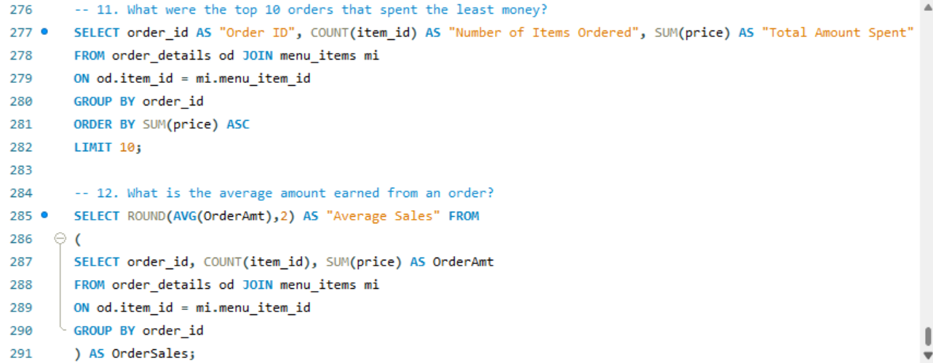

|  |  |  |
| --- | --- | --- |
| Order ID | Number of Times Ordered | Total Amount Spent |
| 349 | 1 | 5.00 |
| 150 | 1 | 5.00 |
| 371 | 1 | 5.00 |
| 211 | 1 | 5.00 |
| 112 | 1 | 5.00 |
| 132 | 1 | 5.00 |
| 84 | 1 | 5.00 |
| 127 | 1 | 5.00 |
| 398 | 1 | 5.00 |
| 259 | 1 | 5.00 |



